Pafe issue with interrupted excel. Resolution steps-

1. Close all the excel in local machine.
2. Open File Explorer and type %AppData% in Navigation pane, click enter.

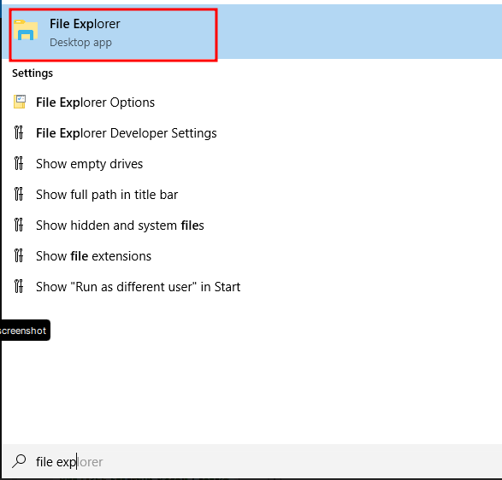

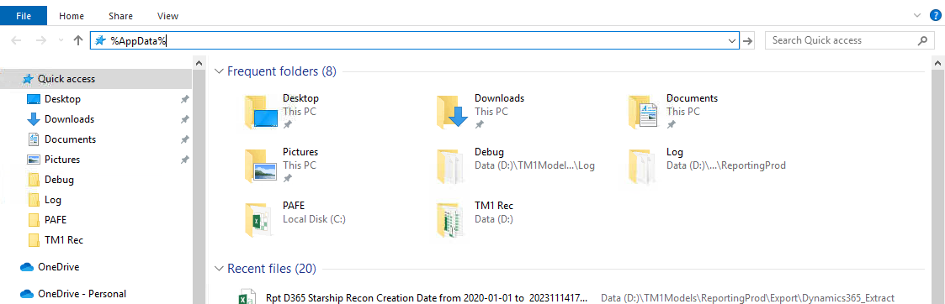

1. Get back one step in navigation pane by clicking AppData as per below screenshot.

1. Navigate to AppData -> Local -> Cognos folder and there will be a folder named “Office Connection”. Delete the folder. Start the excel.

1. Pafe connections need to be enabled to access the TM1 application. Click the “IBM Planning Analytics” ribbon and click connect. Click New Connection. A pop-up window will be opened where Connection URL and Friendly name need to be provided.

Connection URL:

**Connection URL** – [provide](http://aumel-tm1paw.peaktrav.com) the connection URL

**Friendly Name** – Any name

Click Test Connection, it should show the successful message and then Save it.

Login to Pafe with the provided friendly name.